Lab Sheet 2

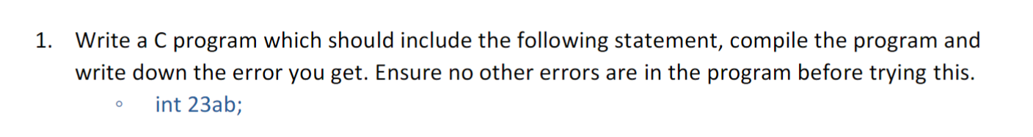

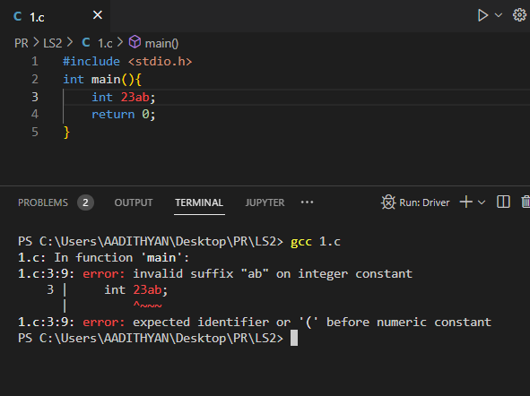

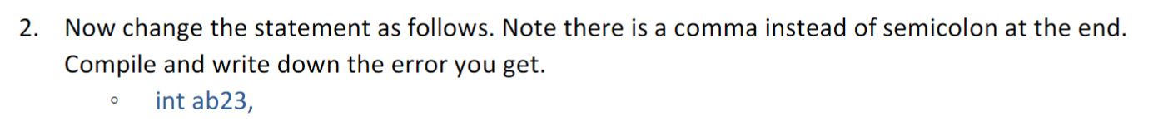

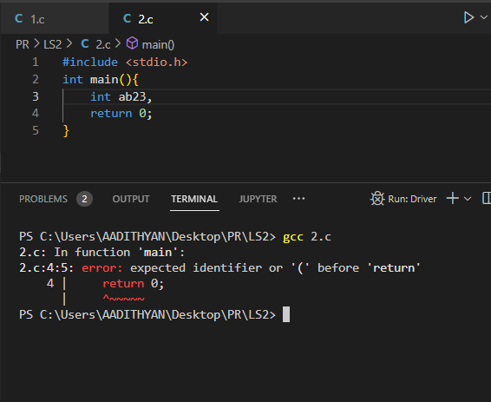

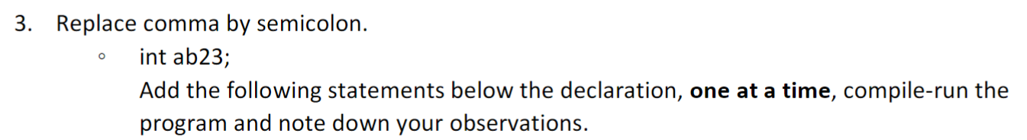

1. ab23=25;

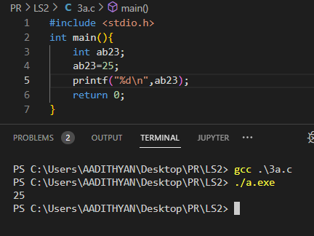

No Error, proper output.

1. ab23=25.25;

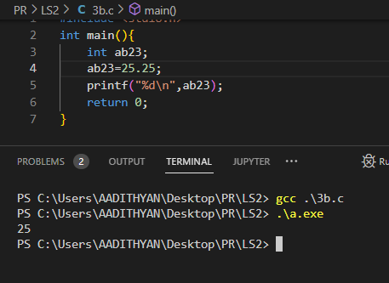

No error, 25.25 is converted from double to integer then printed.

1. ab23=’Z’;

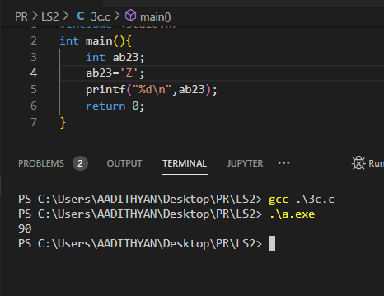

No error, ‘Z’ is converted into ascii and the decimal value is printed.

1. ab23=”hello”;

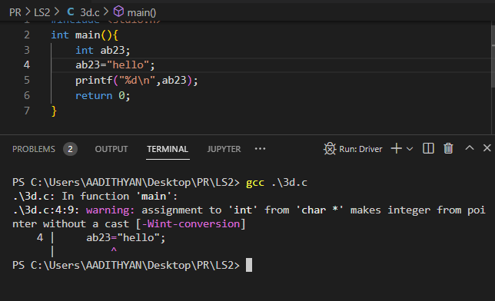

Error, in C string is an array of characters so it can’t be assigned to an integer variable.

1. int ab23; // i.e. another declaration

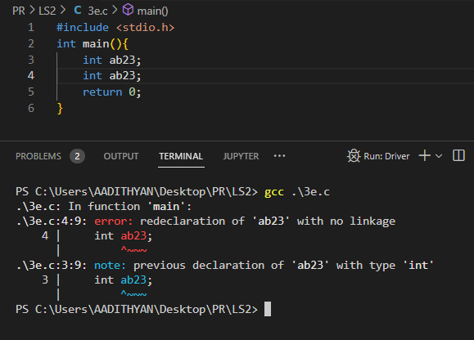

Can’t redeclare variables in the same block.

1. int ab23[5]; // i.e. declare array variable with same name.

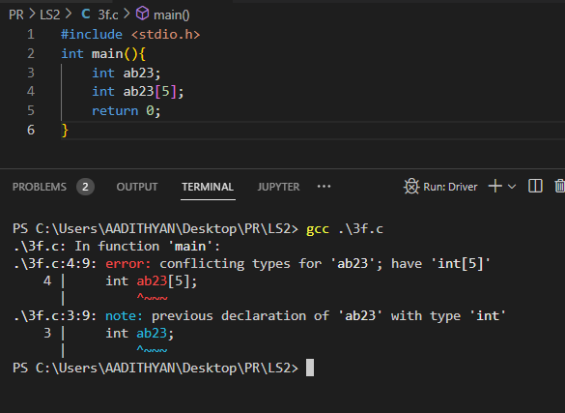

1. void ab23();// i.e. declare function prototype with same name .

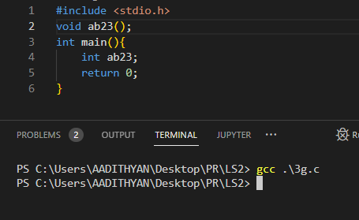

No error as ab23() is a function while ab23 is a int variable.

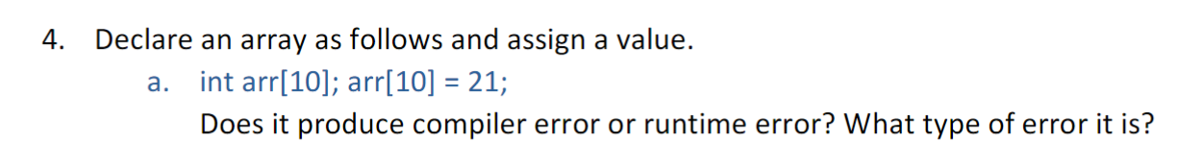

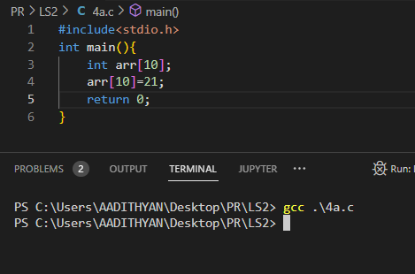

No error came, while I think there should have been a error saying that index of arr 10 is not defined or out of range [0,9] etc.

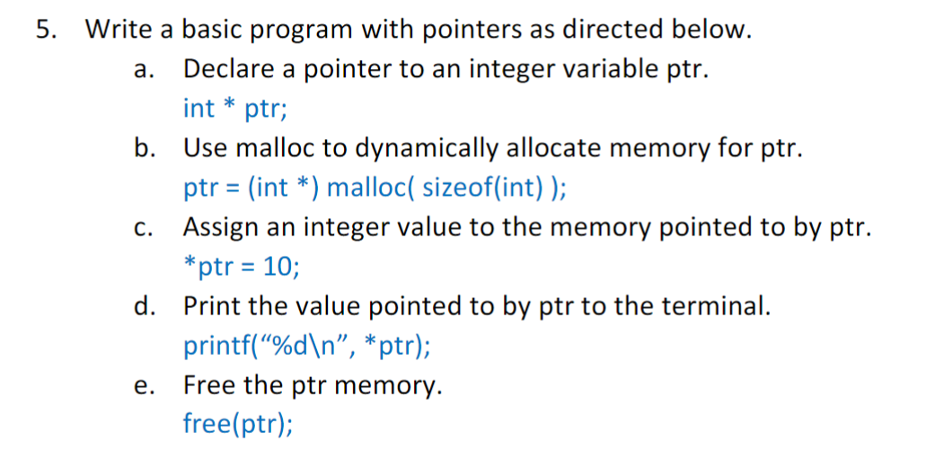

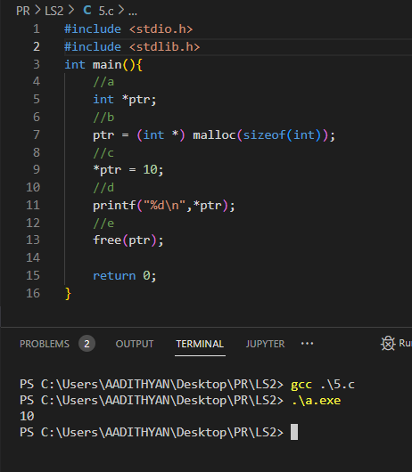

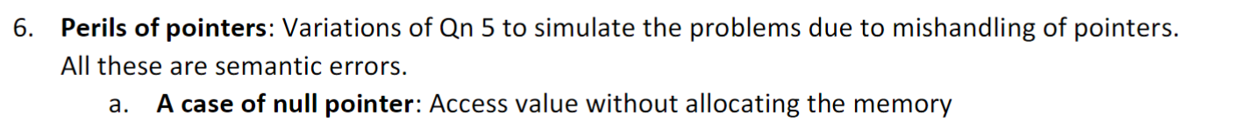

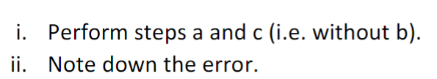

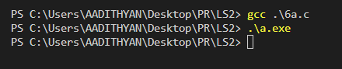

No output

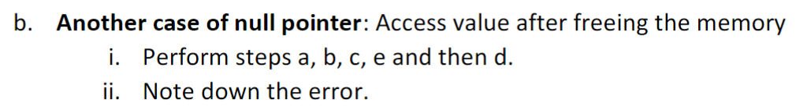

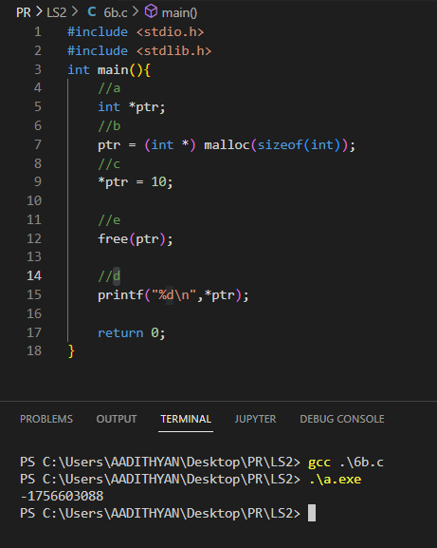

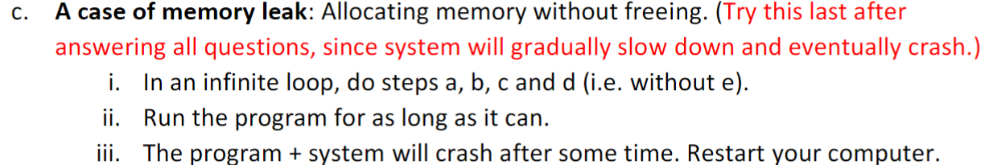

Ram overload, system crash after destroying 32gb virtual ram.

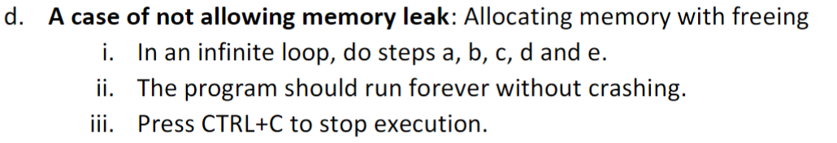

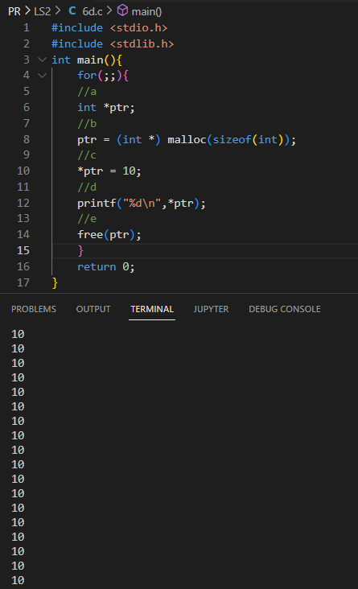

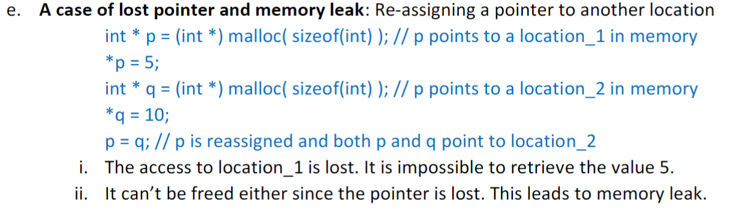

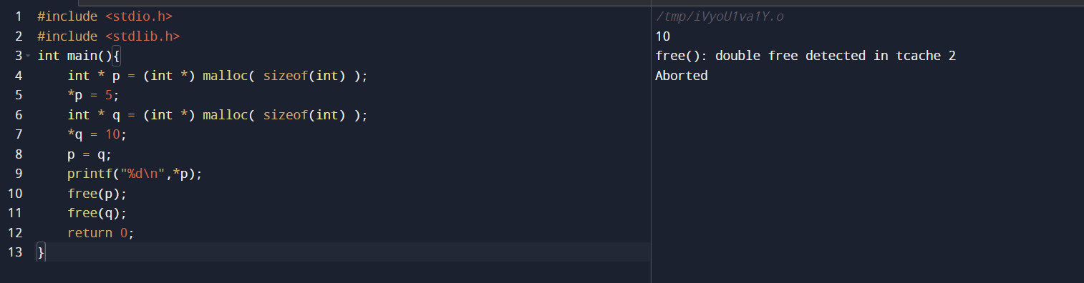

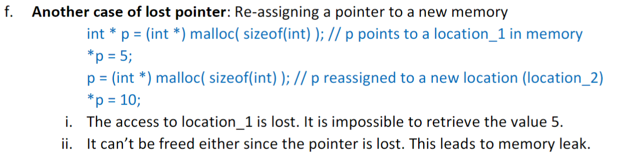

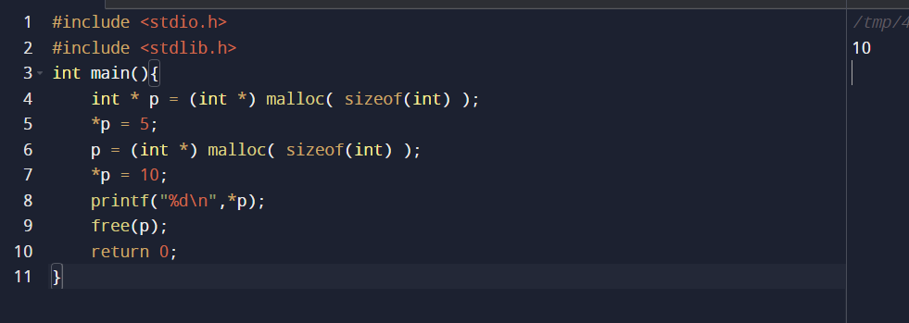

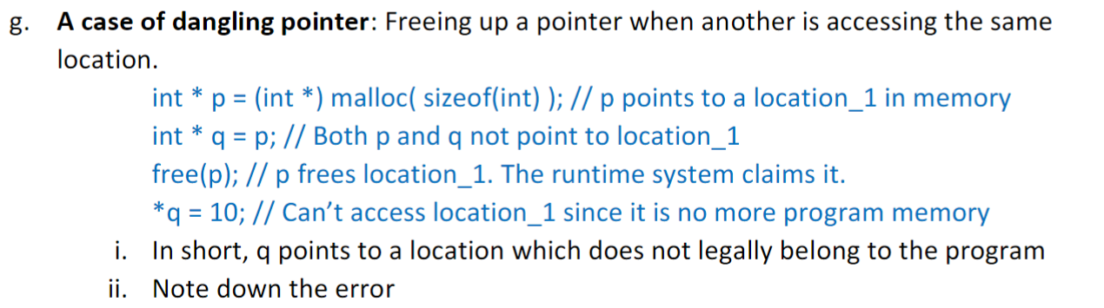

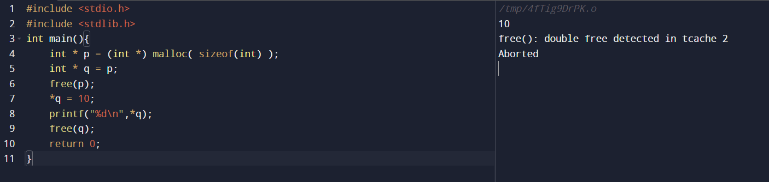

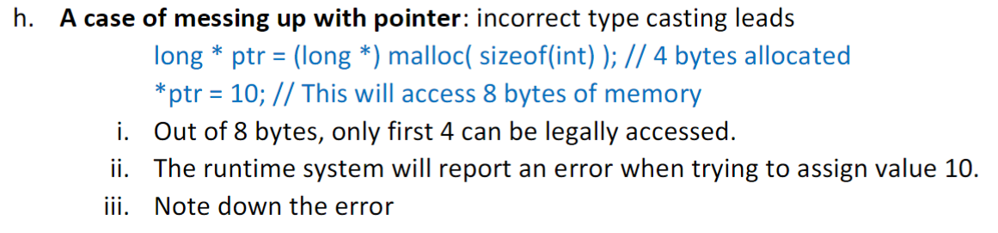

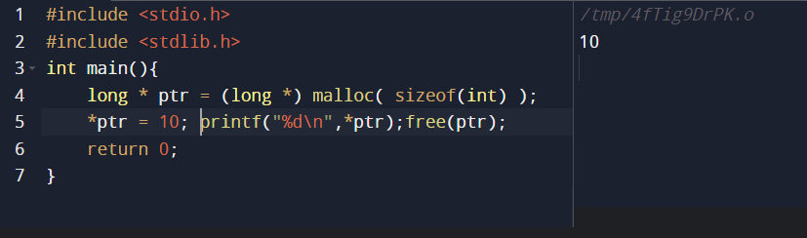

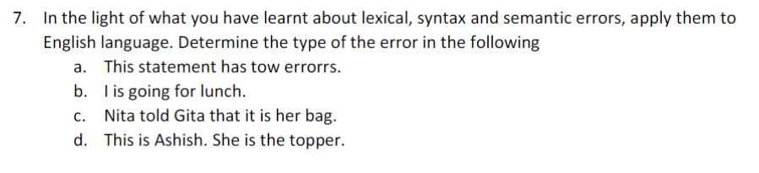

1. lexical (tow)
2. syntax (is)
3. .
4. Sematic ( pronoun she )

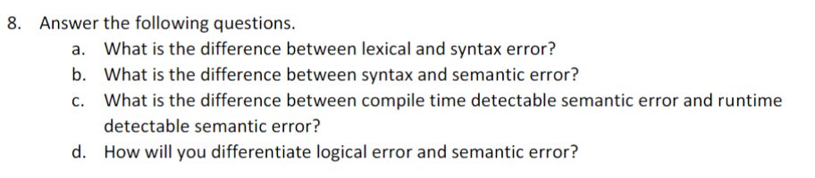

1. Lexical error is when the error is with individual words whereas syntax error is where error happens in forming each line of the code (I e. grammar of a sentence).
2. syntax error is where error happens in forming each line of the code (I e. grammar of a sentence) whereas semantic error happens when the any part mismatch with rest of the program it can be caused by syntax or logical errors.
3. Compile time detectable sematic error are lexical or syntax errors where as runtime detectable semantic errors are logical error pointer override etc.
4. If a program is correct in lexically and by syntax but the given output is not the required output then it is logical error whereas semantic errors can be lexical or by syntax or a part of the program doesn’t match with the rest of the program.

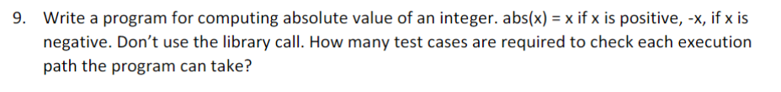

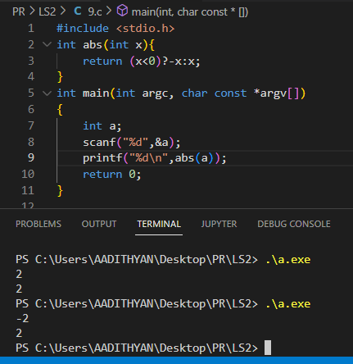

2 paths if a is less than 0 then it prints -a else it prints a

Possibilities of values of a is 4,294,967,296.

Possibilities of output is = 2,147,483,648

